Adding Structure to Your Page in HTML:

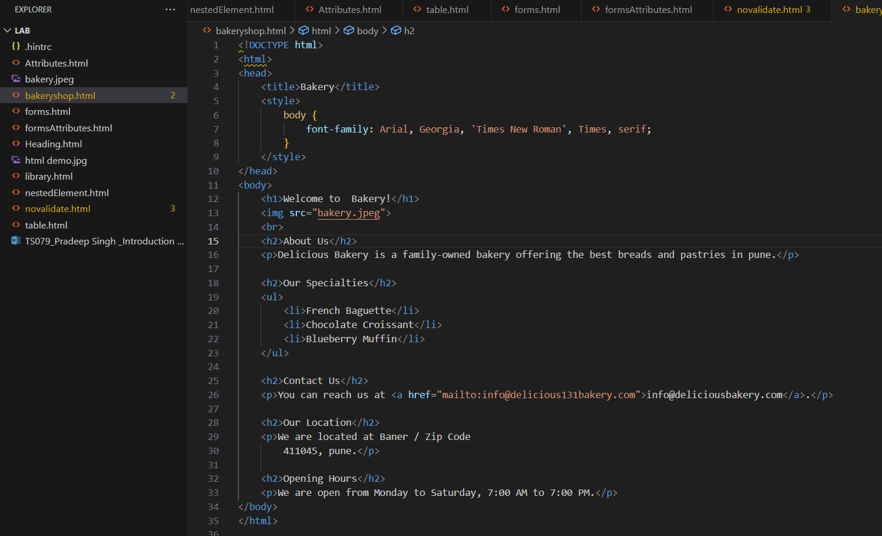



**Steps folled during coding:**

**Expand your index.html file:**Start by opening index.html file in a text editor. This will be the file where you’ll add your HTML code.

**Add headings:** Use the <h1> to <h6> tags to add headings to your webpage. The <h1> tag is the highest level and is usually used for the main title, while <h2> to <h6> tags are used for subheadings.

**Add paragraphs:** Use the <p> tag to add paragraphs to webpage. This tag is used for normal text.

**Add lists**: Use the <ul> tag for unordered lists and the <li> tag for list items. These tags are used to create a list of items.

**Experiment with different HTML tags and attributes:** using different HTML tags such as <div>, <span>, <img>, etc., and experiment with their attributes to understand how they affect the content and layout of your webpage.

**Save the changes:**After adding and modifying your HTML code, save the changes in your index.html file.

In above small project called Bakery shop I have used different tags and attributes and below is the output of the code.

